Portland State Aerospace Society
Initial LV2 airframe simulations

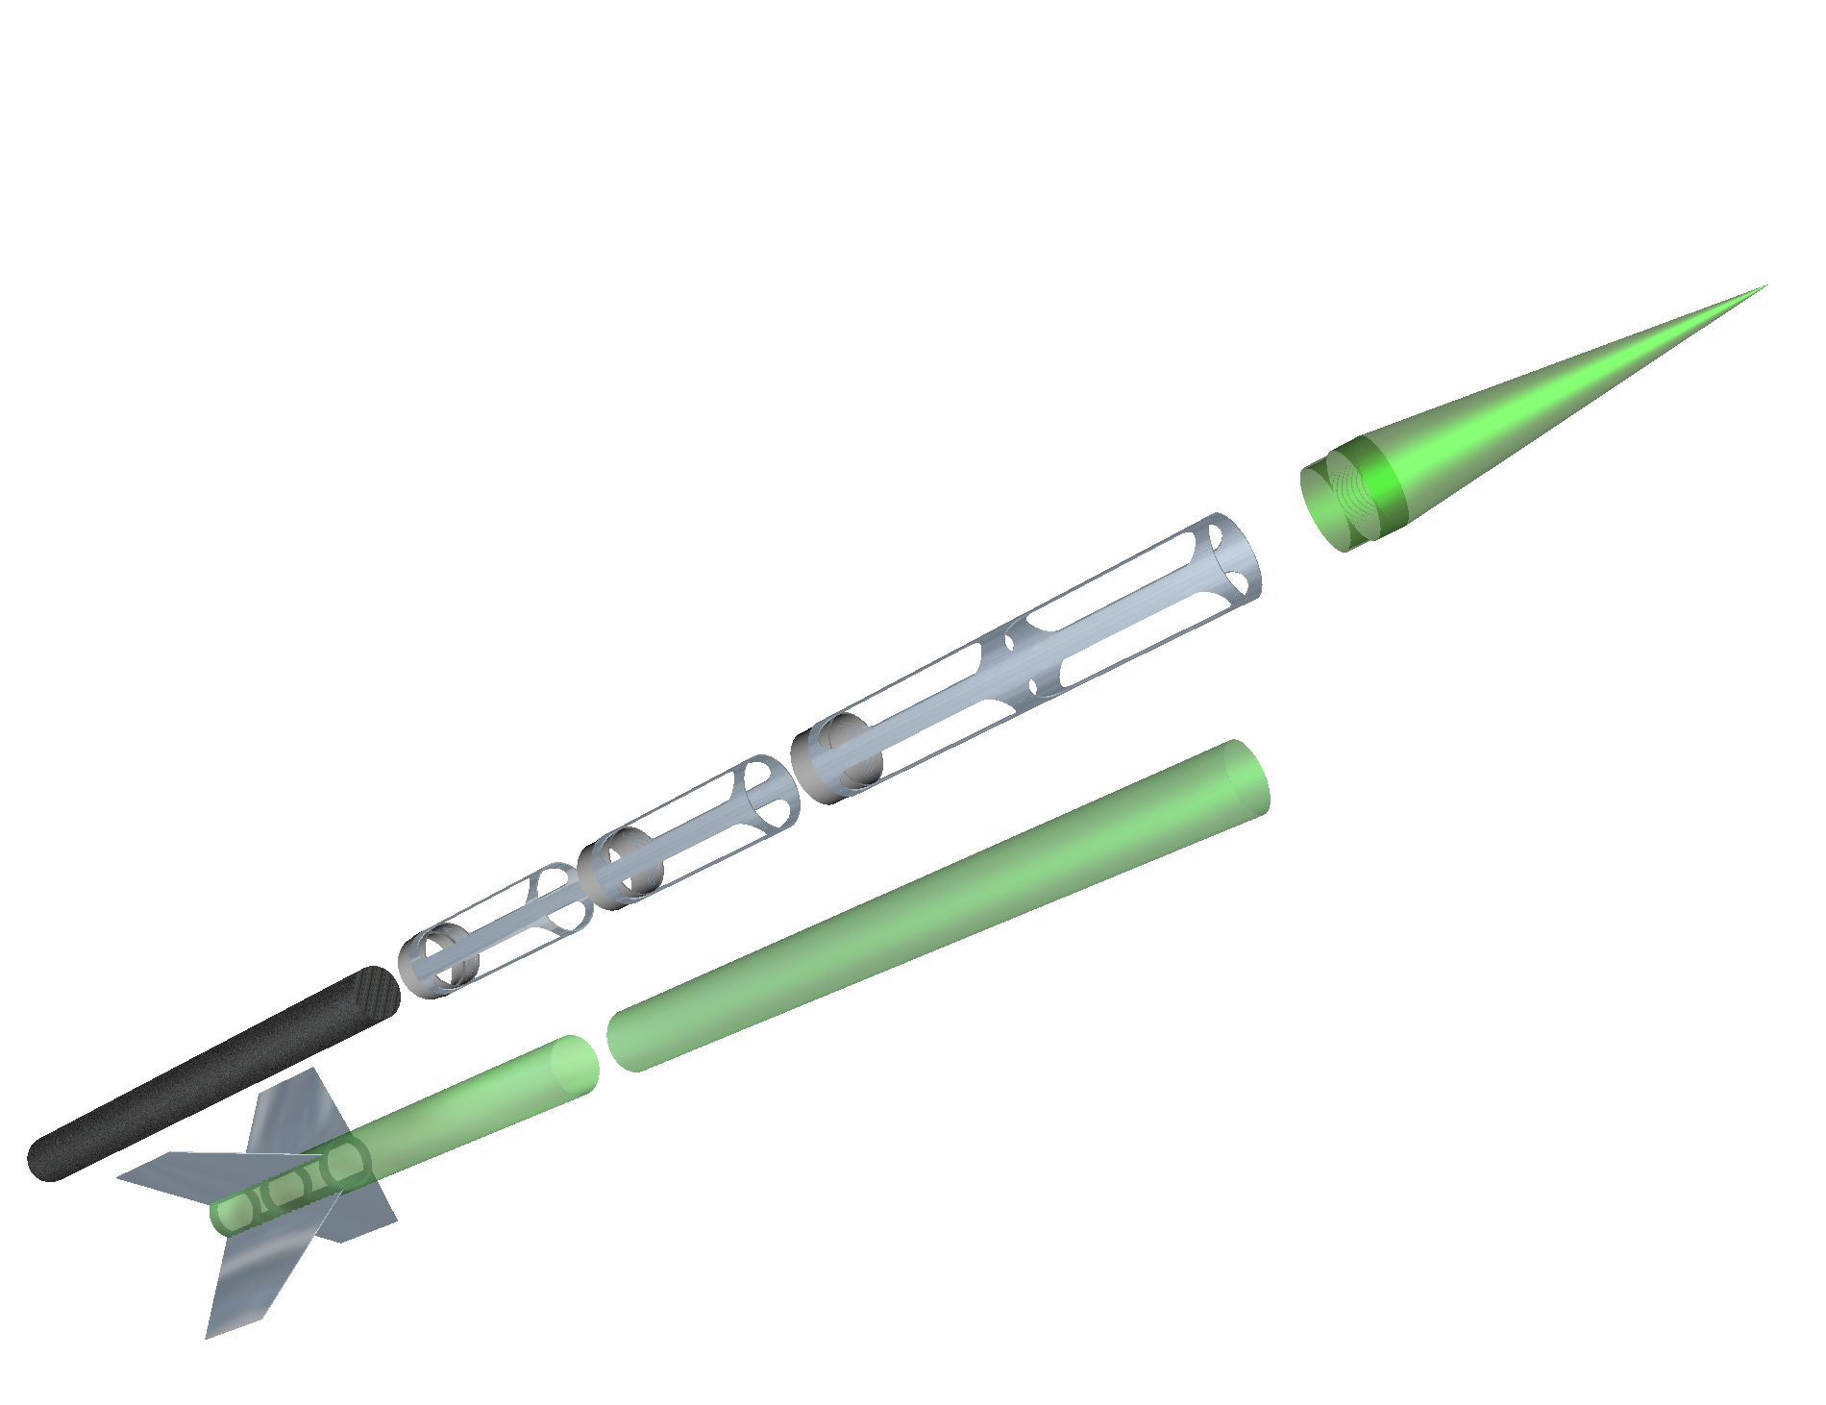

January 23, 2001
Version 1.01

LV2 Airframe Team: Brian O’Neel, Maggie Kubit, Roger Johnson, Cathy Mosher, and Tim Brandon
Introduction

The following is a preliminary look at the LV2 airframe and how it will perform given a varied mass ratio and varied propulsion parameters.

The team is also performing Finite Element Analysis to determine the optimal configuration and weights of the final vehicle components. Therefore the information in this document is meant to help in this process and does not necessarily reflect how the final vehicle will be configured.

Three different vehicle weights and dimensions were selected based on hypothesized final target weights The weight was then varied around the target to see how it would impact the simulations. Three different motors were selected based on a current ‘best guess’ approximation of what the final motor will produce. The burn times were varied between two extremes (4-10 seconds) of what is manufacturable.

For comparison purposes, a base line vehicle weight of 100 lbs was established to help get an idea of how varying parameters will affect the final vehicle altitude.

Given:

Configuration A: This is a non-optimized vehicle based on current materials and designs. It uses some of the components that have been prototyped already. The vehicle uses a thicker aero-shell and large fins to insure stability. The weights are roughly calculated and can vary. Assumptions on avionics and recovery system weights along with other estimated components are made. It is most likely a feasible target weight.

Configuration B: This is a more optimized vehicle based on current materials and design. It uses a thinner aero-shell and lighter couplers along with a reduced fin area that still gives an acceptable static margin of stability. The weights are roughly calculated and can vary. Assumptions on avionics and recovery system weights along with other estimated components are made. It may be a more difficult target weight to achieve.

Configuration C: This is a minimum diameter rocket. The airframe modules will be the same outside diameter as the propulsion unit. Instead of the current 6.25” diameter modules they would be reduced to 5.50”. This will reduce the weight of the final vehicle. This will also reduce the cross sectional area, thereby reducing the drag. The final estimated vehicle weight of 83.33lbs was selected to generate a propellant mass fraction of 0.60. Vehicle component weight calculations have not yet been done to determine exact mass ratio but it seems to be an achievable goal given the geometry of the vehicle and existing material.

P11000: This motor is modeled around fuel characterizations of earlier successful smaller scale motor tests. The motor has an average thrust of approximately 2500lbs for 4 seconds. The total fuel weight is 50lbs with a specific impulse of 205. The burn time of this motor was selected based on burn rates that have been characterized in earlier sub-scale tests.

P5700: This motor is modeled around fuel characterizations of earlier successful smaller scale motor tests. The motor has an average thrust of approximately 1300lbs for 8 seconds. The total fuel weight is 50lbs with a specific impulse of 205. The burn time of this motor was selected to be 8 seconds because this is most near to the burn time of the final flight article motor

P4500: This motor is modeled around fuel characterizations of earlier successful smaller scale motor tests. The motor has an average thrust of approximately 1000lbs for 10 seconds. The total fuel weight is 50lbs with a specific impulse of 205. The burn time of this motor was selected to be 10 seconds because this is a feasible long burn time and will help in determining how burn time effects the flight profile

LV2 Estimated Vehicle Weights:
Weight (oz.) Reference Center of Mass LV2A(heavy) LV2B(light) LV2C(min)
distance (in.) distance (in.) Configuration configuration Configuration
(from base) (from base)
(LV2A. Config.)

Nose cone 18.8 137 145 x x unknown

Nose separation mechanism 3.0 136 x x 3

Top vehicle aero-skin unknown
0.050" (71.75") 66.4 64 99.75 x
0.020" (71.75") 26.4 64 99.75 x
0.020" (47.75") 17.6 64 87.875
Bottom vehicle aero-skin unknown
0.050" (64.00") 59.2 0 32 x
0.020" (64.00") 23.6 0 32 x

Payload module unknown
36.000" 45.7 117 x x
4.000" 35.3
12.000" 14.9

Payload module coupler 31.0 99 x 16oz. unknown

Recovery system 80.0 90 x x x

Recovery module unknown 18.000" 24.0 90 x x
12.000" 14.9

Recovery module coupler 31.0 81 x 16oz. unknown

Avionics module
18.000" 24.0 72 x x unknown
12.000" 14.9

Avionics 80.0 72 x x x

Avionics module coupler 31.0 63 x x unknown

Fins 12.000" span unknown
Aluminum 168.6 1 10.33 x
Eglass 100.9 1 10.33

Fins 8.000" span unknown
Aluminum 119.9 1 x
Eglass 71.8 1

Fin rings unknown
Aluminum 9.5 13 x x
Eglass 5.7 13

Motor casing 264.0
Motor components lumped together as one unit
Motor nozzle 16.0 1112 oz. Mass element @31.5"
from base reference edge
Motor closures 16.0

Fuel liner 16.0

Fuel 800.0

Total 1784.2oz. 1629.9oz. 1333.3 oz.(target)
Mass Ratio w/ 50lbs fuel
(MR = Mf/Mo) 0.552 0.509 0.400
Propellant Mass Fraction
(PMR = Mp/Mo) 0.448 0.491 0.600

Rocket: LV2A Profile (Heavy configuration)

Motor: P4500  Max Diameter: 6.350  Overall Length: 161.00  Len/Dia ratio: 25.35  Drag method: From file  CD File: LV2A  Launch Lug: No | Launch weight: 111.51  Average Subsonic CD: .5932  Launch site conditions:  Elevation(ft): 4000  Ground launch: Yes  Air temp. (F): 85

Lift-off weight : 111.51 lbs (Mass Ratio = 0.552 / Propellant Mass Fraction = 0.448)
Max altitude : 42380.94 ft. 8.03 miles
Max Mach number : 2.28
Max velocity : 2491.26 ft/sec. (1698.59 mph)
Max acceleration : 8.94 G's at 3.66 sec.
Max deceleration : -10.06 G's at 10.02 sec.
Burnout altitude : 13186.12 ft at 10.01 sec.
Burnout velocity : 2490.85 ft/sec (local Mach 2.279) (1698.31 mph)
Coast time : 38.03 seconds

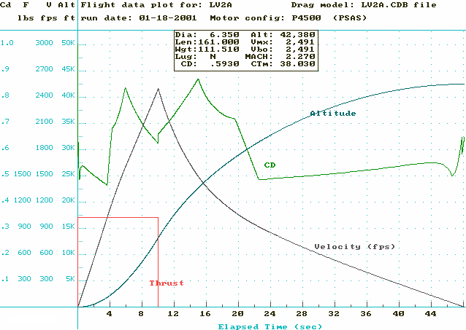
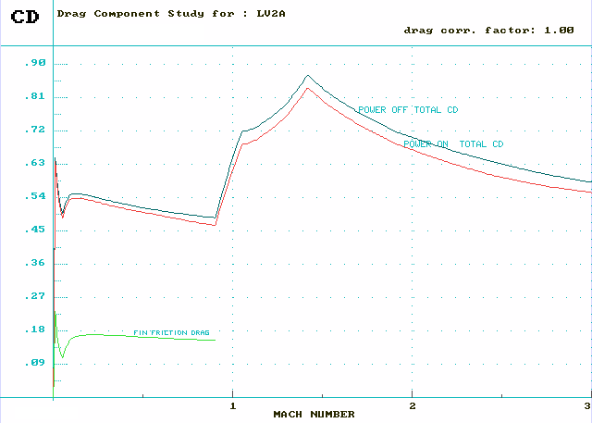

Stepped Run : LV2A profile (80-120 lbs)

Motor Launch Peak B.Out B.Out Alt: Alt: Maximum Max Coast
Weight Altitude Alt % of Feet/ Feet/ Velocity Mach time
(lbs) (ft) (ft) Alt N*Sec gram (ft/sec) Number (sec)
--------------------------------------------------------------------------------------------------------------------
P4500 80.0 43692 17733 40.6 1.0 1.0 3302.01 3.07 33.585
82.0 43913 17367 39.5 1.0 1.0 3235.99 3.01 34.185
84.0 44084 17014 38.6 1.0 1.0 3173.43 2.94 34.715
86.0 44195 16674 37.7 1.0 1.0 3112.95 2.88 35.195
88.0 44253 16345 36.9 1.0 1.0 3054.48 2.83 35.625
90.0 44261 16027 36.2 1.0 1.0 2997.90 2.77 36.005
92.0 44226 15720 35.5 1.0 1.0 2943.13 2.72 36.335
94.0 44152 15423 34.9 1.0 1.0 2890.13 2.67 36.635
96.0 44044 15135 34.4 1.0 1.0 2838.86 2.62 36.895
98.0 43906 14857 33.8 1.0 1.0 2789.22 2.57 37.125
100.0 43739 14587 33.3 1.0 1.0 2741.10 2.52 37.325(baseline)
102.0 43548 14325 32.9 1.0 1.0 2694.45 2.47 37.495
104.0 43334 14072 32.5 1.0 1.0 2649.19 2.43 37.645
106.0 43102 13826 32.1 0.9 0.9 2605.32 2.39 37.775
108.0 42853 13588 31.7 0.9 0.9 2562.82 2.35 37.885
110.0 42589 13356 31.4 0.9 0.9 2521.58 2.31 37.975
112.0 42312 13132 31.0 0.9 0.9 2481.57 2.27 38.045
114.0 42023 12913 30.7 0.9 0.9 2442.71 2.23 38.105
116.0 41725 12701 30.4 0.9 0.9 2404.96 2.20 38.145
118.0 41417 12494 30.2 0.9 0.9 2368.25 2.16 38.175
120.0 41101 12293 29.9 0.9 0.9 2332.57 2.13 38.185

Motor Launch Peak B.Out B.Out Alt: Alt: Maximum Max Coast
Weight Altitude Alt % of Feet/ Feet/ Velocity Mach time
(lbs) (ft) (ft) Alt N*Sec gram (ft/sec) Number (sec)
--------------------------------------------------------------------------------------------------------------------
P5700 80.0 40524 15026 37.1 0.9 0.9 3556.33 3.27 32.675
82.0 40813 14702 36.0 0.9 0.9 3478.87 3.20 33.305
84.0 41059 14391 35.0 0.9 0.9 3406.29 3.13 33.875
86.0 41268 14091 34.1 0.9 0.9 3338.08 3.06 34.405
88.0 41442 13803 33.3 0.9 0.9 3273.68 3.00 34.895
90.0 41576 13524 32.5 0.9 0.9 3212.04 2.94 35.345
92.0 41662 13255 31.8 0.9 0.9 3152.23 2.88 35.745
94.0 41706 12996 31.2 0.9 0.9 3094.25 2.83 36.105
96.0 41710 12745 30.6 0.9 0.9 3038.01 2.77 36.425
98.0 41678 12502 30.0 0.9 0.9 2983.41 2.72 36.705
100.0 41615 12268 29.5 0.9 0.9 2930.51 2.67 36.965(baseline)
102.0 41523 12041 29.0 0.9 0.9 2879.21 2.62 37.195
104.0 41406 11821 28.6 0.9 0.9 2829.48 2.58 37.395
106.0 41264 11609 28.1 0.9 0.9 2781.21 2.53 37.565
108.0 41101 11403 27.7 0.9 0.9 2734.36 2.49 37.725
110.0 40919 11203 27.4 0.9 0.9 2688.83 2.44 37.855
112.0 40720 11010 27.0 0.9 0.9 2644.69 2.40 37.965
114.0 40506 10822 26.7 0.9 0.9 2601.86 2.36 38.065
116.0 40279 10640 26.4 0.9 0.9 2560.25 2.32 38.145
118.0 40039 10463 26.1 0.9 0.9 2519.83 2.28 38.215
120.0 39789 10291 25.9 0.9 0.9 2480.59 2.25 38.265

P11000 80.0 34372 8725 25.4 0.8 0.8 4441.86 4.00 31.175
82.0 34777 8503 24.5 0.8 0.8 4316.21 3.88 31.855
84.0 35139 8293 23.6 0.8 0.8 4199.27 3.77 32.485
86.0 35462 8093 22.8 0.8 0.8 4089.96 3.67 33.065
88.0 35750 7902 22.1 0.8 0.8 3987.44 3.58 33.605
90.0 36003 7721 21.4 0.8 0.8 3890.99 3.49 34.105
92.0 36226 7547 20.8 0.8 0.8 3799.99 3.41 34.565
94.0 36421 7381 20.3 0.8 0.8 3713.92 3.33 35.005
96.0 36590 7222 19.7 0.8 0.8 3632.33 3.25 35.405
98.0 36734 7069 19.2 0.8 0.8 3554.81 3.18 35.775
100.0 36856 6922 18.8 0.8 0.8 3481.02 3.11 36.125(baseline)
102.0 36956 6781 18.3 0.8 0.8 3410.68 3.05 36.445
104.0 37038 6645 17.9 0.8 0.8 3343.50 2.99 36.755
106.0 37093 6514 17.6 0.8 0.8 3278.85 2.93 37.025
108.0 37118 6388 17.2 0.8 0.8 3216.37 2.87 37.275
110.0 37117 6267 16.9 0.8 0.8 3155.97 2.82 37.505
112.0 37090 6149 16.6 0.8 0.8 3097.55 2.76 37.705
114.0 37040 6036 16.3 0.8 0.8 3041.06 2.71 37.885
116.0 36969 5926 16.0 0.8 0.8 2986.39 2.66 38.045
118.0 36880 5820 15.8 0.8 0.8 2933.51 2.61 38.195
120.0 36773 5718 15.5 0.8 0.8 2882.32 2.57 38.315

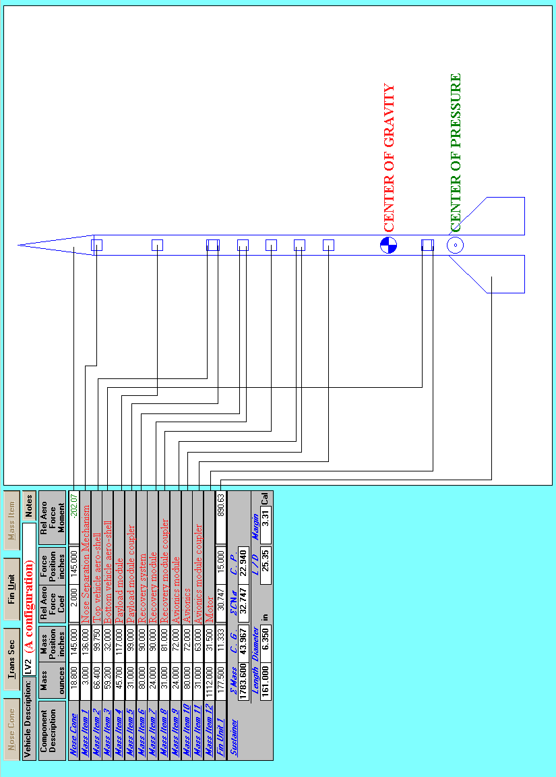

LV2A Configuration

Rocket: LV2B Profile (Light configuration)

Motor: P4500  Max Diameter: 6.290  Overall Length: 161.00  Len/Dia ratio: 25.59  Drag method: From file  CD File: LV2B  Launch Lug: No | Launch weight: 101.87  Average Subsonic CD: .4822  Launch site conditions:  Elevation(ft): 4000  Ground launch: Yes  Air temp. (F): 85

Lift-off weight : 101.87 lbs (Mass Ratio = 0.509 / Propellant Mass Fraction = 0.491)
Max altitude : 53011.14 ft. 10.04 miles
Max Mach number : 2.68
Max velocity : 2909.42 ft/sec. (1983.69 mph)
Max acceleration : 10.09 G's at 3.29 sec.
Max deceleration : -11.27 G's at 10.02 sec.
Burnout altitude : 14948.46 ft at 10.01 sec.
Burnout velocity : 2909.18 ft/sec (local Mach 2.679) (1983.53 mph)
Coast time : 43.47 seconds

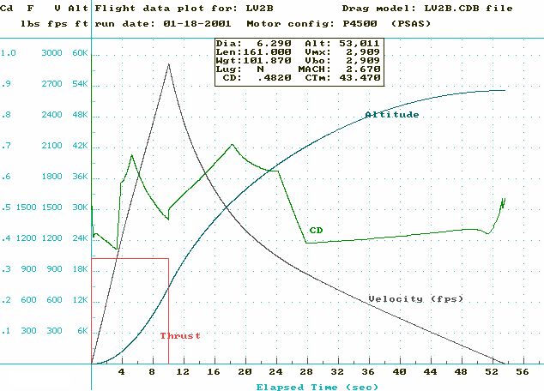

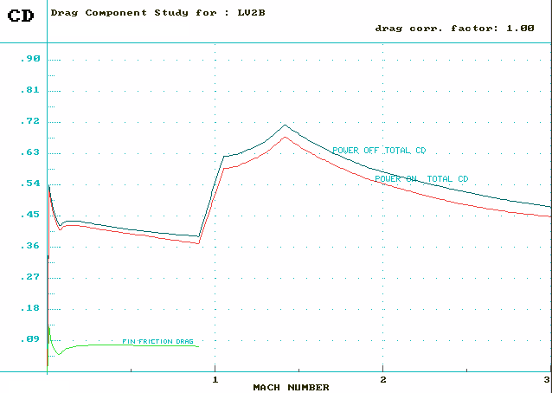

Stepped Run : LV2B profile (80-120 lbs)

Motor Launch Peak B.Out B.Out Alt: Alt: Maximum Max Coast
Weight Altitude Alt % of Feet/ Feet/ Velocity Mach time
(lbs) (ft) (ft) Alt N*Sec gram (ft/sec) Number (sec)
--------------------------------------------------------------------------------------------------------------------
P4500 80.0 56000 18860 33.7 1.2 1.2 3686.24 3.44 41.085
82.0 55926 18426 32.9 1.2 1.2 3592.69 3.35 41.525
84.0 55800 18012 32.3 1.2 1.2 3505.67 3.26 41.905
86.0 55633 17614 31.7 1.2 1.2 3424.47 3.18 42.235
88.0 55430 17233 31.1 1.2 1.2 3348.38 3.11 42.515
90.0 55197 16867 30.6 1.2 1.2 3276.80 3.04 42.765
92.0 54936 16514 30.1 1.2 1.2 3209.12 2.97 42.985
94.0 54626 16174 29.6 1.2 1.2 3144.07 2.91 43.155
96.0 54269 15846 29.2 1.2 1.2 3081.36 2.85 43.285
98.0 53871 15530 28.8 1.2 1.2 3020.78 2.79 43.375
100.0 53440 15224 28.5 1.2 1.2 2962.27 2.73 43.435(baseline)
102.0 52981 14930 28.2 1.2 1.2 2905.81 2.67 43.465
104.0 52499 14645 27.9 1.2 1.2 2851.25 2.62 43.475
106.0 52000 14369 27.6 1.1 1.1 2798.54 2.57 43.455
108.0 51486 14103 27.4 1.1 1.1 2747.57 2.52 43.425
110.0 50959 13845 27.2 1.1 1.1 2698.25 2.47 43.375
112.0 50423 13595 27.0 1.1 1.1 2650.47 2.43 43.305
114.0 49880 13353 26.8 1.1 1.1 2604.30 2.38 43.225
116.0 49335 13118 26.6 1.1 1.1 2559.62 2.34 43.135
118.0 48786 12891 26.4 1.1 1.1 2516.35 2.30 43.035
120.0 48235 12670 26.3 1.1 1.1 2474.42 2.26 42.935
Motor Launch Peak B.Out B.Out Alt: Alt: Maximum Max Coast
Weight Altitude Alt % of Feet/ Feet/ Velocity Mach time
(lbs) (ft) (ft) Alt N*Sec gram (ft/sec) Number (sec)
--------------------------------------------------------------------------------------------------------------------
P5700 80.0 51820 15888 30.7 1.1 1.1 3942.74 3.64 39.655
82.0 51907 15509 29.9 1.1 1.1 3838.02 3.54 40.185
84.0 51939 15147 29.2 1.1 1.1 3740.64 3.45 40.645
86.0 51923 14801 28.5 1.1 1.1 3649.70 3.36 41.065
88.0 51866 14470 27.9 1.1 1.1 3564.38 3.28 41.425
90.0 51772 14153 27.3 1.1 1.1 3484.13 3.20 41.755
92.0 51647 13849 26.8 1.1 1.1 3408.44 3.12 42.035
94.0 51494 13557 26.3 1.1 1.1 3336.79 3.06 42.285
96.0 51316 13275 25.9 1.1 1.1 3268.80 2.99 42.515
98.0 51101 13004 25.4 1.1 1.1 3203.52 2.93 42.705
100.0 50842 12743 25.1 1.1 1.1 3140.50 2.87 42.855(baseline)
102.0 50545 12490 24.7 1.1 1.1 3079.56 2.81 42.965
104.0 50214 12247 24.4 1.1 1.1 3020.66 2.75 43.055
106.0 49856 12012 24.1 1.1 1.1 2963.77 2.70 43.115
108.0 49474 11785 23.8 1.1 1.1 2908.78 2.65 43.145
110.0 49073 11565 23.6 1.1 1.1 2855.57 2.60 43.165
112.0 48656 11353 23.3 1.1 1.1 2804.10 2.55 43.165
114.0 48225 11148 23.1 1.1 1.1 2754.27 2.50 43.145
116.0 47781 10949 22.9 1.0 1.0 2705.98 2.46 43.105
118.0 47328 10756 22.7 1.0 1.0 2659.22 2.41 43.055
120.0 46867 10570 22.6 1.0 1.0 2613.92 2.37 42.995

P11000 80.0 43692 9059 20.7 1.0 1.0 4759.80 4.29 37.115
82.0 44193 8814 19.9 1.0 1.0 4618.03 4.16 37.845
84.0 44543 8582 19.3 1.0 1.0 4482.51 4.03 38.475
86.0 44771 8362 18.7 1.0 1.0 4353.93 3.91 39.015
88.0 44945 8153 18.1 1.0 1.0 4233.71 3.80 39.505
90.0 45076 7955 17.6 1.0 1.0 4121.09 3.70 39.945
92.0 45168 7766 17.2 1.0 1.0 4015.25 3.60 40.345
94.0 45224 7586 16.8 1.0 1.0 3915.49 3.51 40.705
96.0 45248 7413 16.4 1.0 1.0 3821.28 3.42 41.035
98.0 45244 7249 16.0 1.0 1.0 3732.09 3.34 41.325
100.0 45214 7091 15.7 1.0 1.0 3647.45 3.27 41.595(baseline)
102.0 45161 6940 15.4 1.0 1.0 3567.03 3.19 41.835
104.0 45086 6795 15.1 1.0 1.0 3490.45 3.12 42.055
106.0 44992 6656 14.8 1.0 1.0 3417.42 3.05 42.245
108.0 44882 6522 14.5 1.0 1.0 3347.67 2.99 42.425
110.0 44744 6393 14.3 1.0 1.0 3280.67 2.93 42.575
112.0 44576 6269 14.1 1.0 1.0 3216.10 2.87 42.695
114.0 44379 6149 13.9 1.0 1.0 3153.82 2.81 42.795
116.0 44157 6033 13.7 1.0 1.0 3093.70 2.76 42.875
118.0 43912 5922 13.5 1.0 1.0 3035.66 2.71 42.935
120.0 43649 5814 13.3 1.0 1.0 2979.64 2.66 42.975

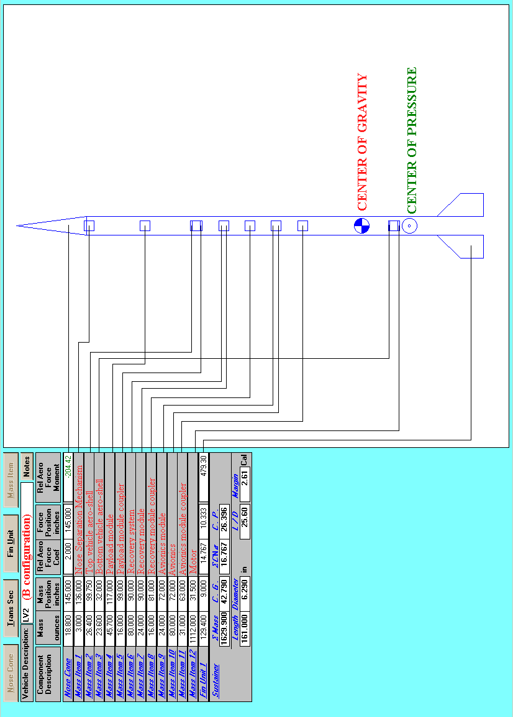

LV2B Configuration

Rocket: LV2C Profile (Minimum diameter configuration)

Motor: P4500  Max Diameter: 5.500  Overall Length: 161.00  Len/Dia ratio: 29.27  Drag method: From file  CD File: LV2C  Launch Lug: No | Launch weight: 83.333  Average Subsonic CD: .5569  Launch site conditions:  Elevation(ft): 4000  Ground launch: Yes  Air temp. (F): 85

Lift-off weight : 83.33 lbs (Mass Ratio = 0.400 / Propellant Mass Fraction = 0.600)
Max altitude : 70086.94 ft. 13.27 miles
Max Mach number : 3.54
Max velocity : 3793.36 ft/sec. (2586.38 mph)
Max acceleration : 14.85 G's at 10.00 sec.
Max deceleration : -16.92 G's at 10.02 sec.
Burnout altitude : 18886.42 ft at 10.01 sec.
Burnout velocity : 3793.20 ft/sec (local Mach 3.544) (2586.27 mph)
Coast time : 50.00 seconds

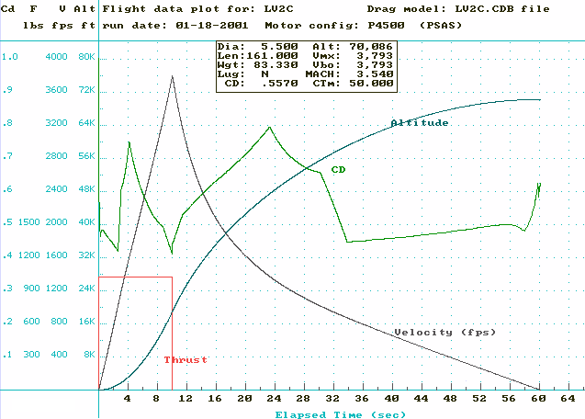
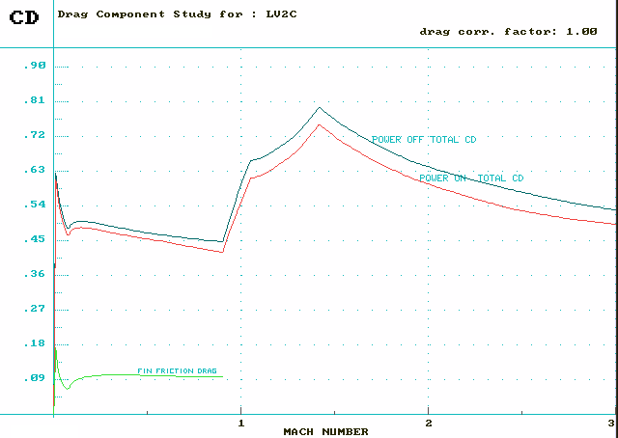

Stepped Run : LV2C profile (80-120 lbs)

Motor Launch Peak B.Out B.Out Alt: Alt: Maximum Max Coast
Weight Altitude Alt % of Feet/ Feet/ Velocity Mach time
(lbs) (ft) (ft) Alt N*Sec gram (ft/sec) Number (sec)
--------------------------------------------------------------------------------------------------------------------
P4500 80.0 71364 19685 27.6 1.6 1.6 3978.70 3.73 49.885
82.0 70604 19198 27.2 1.5 1.5 3864.60 3.61 49.965
84.0 69825 18734 26.8 1.5 1.5 3759.01 3.51 50.005
86.0 69035 18293 26.5 1.5 1.5 3660.87 3.41 50.005
88.0 68240 17871 26.2 1.5 1.5 3569.24 3.32 49.985
90.0 67443 17468 25.9 1.5 1.5 3483.37 3.24 49.935
92.0 66650 17081 25.6 1.5 1.5 3402.67 3.16 49.865
94.0 65861 16710 25.4 1.4 1.4 3326.57 3.08 49.785
96.0 65082 16353 25.1 1.4 1.4 3254.62 3.01 49.685
98.0 64300 16009 24.9 1.4 1.4 3186.08 2.94 49.575
100.0 63487 15678 24.7 1.4 1.4 3120.10 2.88 49.435(baseline)
102.0 62653 15360 24.5 1.4 1.4 3056.54 2.82 49.265
104.0 61801 15052 24.4 1.4 1.4 2995.20 2.76 49.075
106.0 60940 14755 24.2 1.3 1.3 2936.02 2.70 48.875
108.0 60076 14469 24.1 1.3 1.3 2878.95 2.65 48.655
110.0 59211 14192 24.0 1.3 1.3 2823.86 2.59 48.425
112.0 58349 13924 23.9 1.3 1.3 2770.65 2.54 48.185
114.0 57492 13666 23.8 1.3 1.3 2719.19 2.49 47.935
116.0 56642 13415 23.7 1.2 1.2 2669.44 2.44 47.685
118.0 55803 13173 23.6 1.2 1.2 2621.34 2.40 47.435
120.0 54976 12938 23.5 1.2 1.2 2574.83 2.35 47.185
Motor Launch Peak B.Out B.Out Alt: Alt: Maximum Max Coast
Weight Altitude Alt % of Feet/ Feet/ Velocity Mach time
(lbs) (ft) (ft) Alt N*Sec gram (ft/sec) Number (sec)
--------------------------------------------------------------------------------------------------------------------
P5700 80.0 65580 16508 25.2 1.4 1.4 4225.41 3.91 47.675
82.0 65171 16086 24.7 1.4 1.4 4100.91 3.79 47.935
84.0 64715 15687 24.2 1.4 1.4 3985.64 3.68 48.135
86.0 64222 15307 23.8 1.4 1.4 3878.35 3.58 48.295
88.0 63704 14944 23.5 1.4 1.4 3778.14 3.48 48.415
90.0 63165 14599 23.1 1.4 1.4 3684.20 3.39 48.505
92.0 62612 14268 22.8 1.4 1.4 3595.86 3.30 48.555
94.0 62047 13951 22.5 1.4 1.4 3512.53 3.22 48.595
96.0 61476 13647 22.2 1.3 1.3 3433.76 3.15 48.605
98.0 60900 13356 21.9 1.3 1.3 3359.11 3.07 48.605
100.0 60322 13075 21.7 1.3 1.3 3288.20 3.01 48.575(baseline)
102.0 59730 12805 21.4 1.3 1.3 3220.42 2.94 48.535
104.0 59103 12545 21.2 1.3 1.3 3155.06 2.88 48.465
106.0 58450 12294 21.0 1.3 1.3 3092.01 2.82 48.365
108.0 57774 12052 20.9 1.3 1.3 3031.13 2.76 48.245
110.0 57084 11819 20.7 1.3 1.3 2972.34 2.71 48.105
112.0 56385 11594 20.6 1.2 1.2 2915.60 2.65 47.955
114.0 55680 11376 20.4 1.2 1.2 2860.78 2.60 47.785
116.0 54971 11166 20.3 1.2 1.2 2807.79 2.55 47.615
118.0 54263 10962 20.2 1.2 1.2 2756.55 2.50 47.425
120.0 53556 10765 20.1 1.2 1.2 2706.98 2.45 47.235

P11000 80.0 53795 9284 17.3 1.2 1.2 4968.75 4.48 43.205
82.0 54399 9023 16.6 1.2 1.2 4815.61 4.34 43.995
84.0 54771 8777 16.0 1.2 1.2 4669.84 4.20 44.635
86.0 54929 8543 15.6 1.2 1.2 4531.26 4.08 45.135
88.0 54897 8322 15.2 1.2 1.2 4399.66 3.96 45.515
90.0 54790 8113 14.8 1.2 1.2 4276.20 3.84 45.825
92.0 54639 7913 14.5 1.2 1.2 4160.43 3.73 46.095
94.0 54453 7724 14.2 1.2 1.2 4051.57 3.63 46.335
96.0 54236 7543 13.9 1.2 1.2 3948.95 3.54 46.525
98.0 53993 7371 13.7 1.2 1.2 3851.98 3.45 46.695
100.0 53728 7206 13.4 1.2 1.2 3760.16 3.37 46.845(baseline)
102.0 53442 7048 13.2 1.2 1.2 3673.05 3.29 46.955
104.0 53141 6897 13.0 1.2 1.2 3590.25 3.21 47.055
106.0 52826 6752 12.8 1.2 1.2 3511.44 3.14 47.135
108.0 52499 6612 12.6 1.2 1.2 3436.29 3.07 47.185
110.0 52161 6478 12.4 1.1 1.1 3364.53 3.01 47.235
112.0 51807 6350 12.3 1.1 1.1 3295.77 2.94 47.255
114.0 51422 6225 12.1 1.1 1.1 3229.57 2.88 47.255
116.0 51011 6106 12.0 1.1 1.1 3165.80 2.82 47.235
118.0 50577 5991 11.8 1.1 1.1 3104.32 2.77 47.185
120.0 50126 5879 11.7 1.1 1.1 3045.03 2.71 47.125

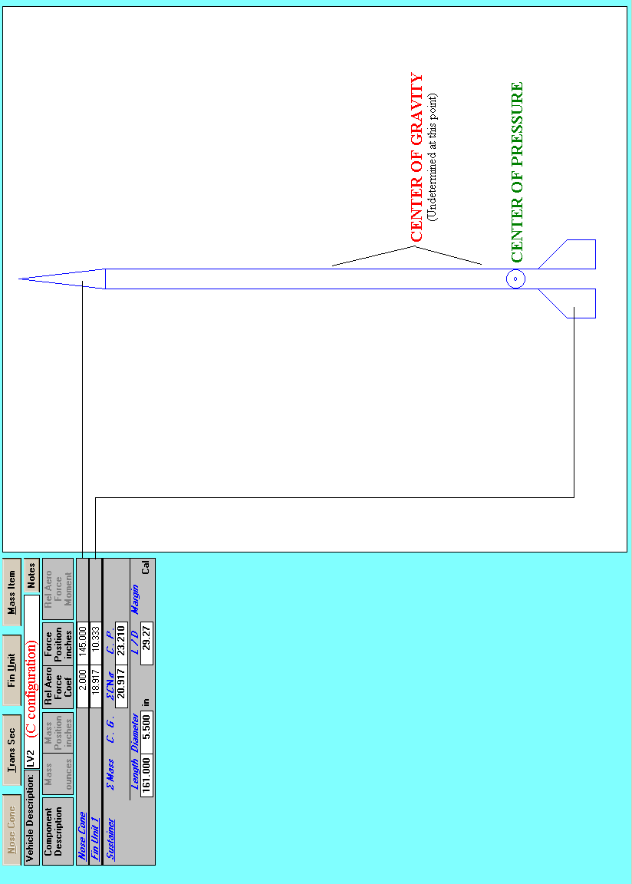

LV2C Configuration

Rocket: LV2D Profile (Minimum diameter configuration)

Motor: P6100  Max Diameter: 5.600  Overall Length: 161.00  Len/Dia ratio: 28.75  Drag method: From file  CD File: LV2D  Launch Lug: No | Launch weight: 83.333  Average Subsonic CD: .5460  Launch site conditions:  Elevation(ft): 4000  Ground launch: Yes  Air temp. (F): 85

Lift-off weight : 83.33 lbs (Mass Ratio = 0.400 / Propellant Mass Fraction = 0.600)
Max altitude : 74,280.67 ft. 14.07 miles
Max Mach number : 4.00
Max velocity : 4309.66 ft/sec. (2938.41 mph)
Max acceleration : 21.95 G's at 8.00 sec.
Max deceleration : -20.49 G's at 8.02 sec.
Burnout altitude : 16884.16ft at 8.01 sec.
Burnout velocity : 4309.66 ft/sec (local Mach 3.997) (2938.41 mph)

Coast time : 52.52 seconds

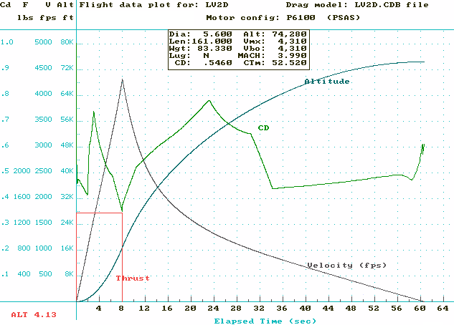

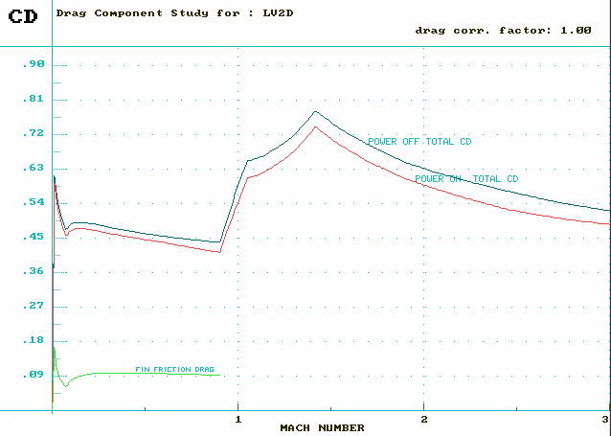

Motor Launch Peak B.Out B.Out Alt: Alt: Maximum Max Coast
Weight Altitude Alt % of Feet/ Feet/ Velocity Mach time
(lbs) (ft) (ft) Alt N*Sec gram (ft/sec) Number (sec)
--------------------------------------------------------------------------------------------------------------------

P6100 80.0 75371 17620 23.4 1.5 1.5 4526.92 4.21 52.295
82.0 74812 17170 23.0 1.5 1.5 4394.43 4.08 52.485
84.0 73983 16744 22.6 1.5 1.5 4268.15 3.96 52.505
86.0 73098 16339 22.4 1.5 1.5 4150.22 3.84 52.475
88.0 72214 15954 22.1 1.5 1.5 4040.33 3.73 52.415
90.0 71335 15586 21.8 1.5 1.5 3937.48 3.63 52.335
92.0 70464 15235 21.6 1.4 1.4 3840.95 3.54 52.235
94.0 69603 14900 21.4 1.4 1.4 3750.04 3.45 52.125
96.0 68754 14578 21.2 1.4 1.4 3664.24 3.37 52.005
98.0 67918 14269 21.0 1.4 1.4 3583.04 3.29 51.875
100.0 67095 13973 20.8 1.4 1.4 3506.00 3.22 51.735(baseline)
102.0 66285 13688 20.6 1.4 1.4 3432.78 3.15 51.585
104.0 65493 13413 20.5 1.3 1.3 3363.09 3.08 51.435
106.0 64717 13148 20.3 1.3 1.3 3296.56 3.02 51.285
108.0 63949 12893 20.2 1.3 1.3 3232.84 2.95 51.125
110.0 63165 12646 20.0 1.3 1.3 3171.28 2.90 50.945
112.0 62365 12408 19.9 1.3 1.3 3111.75 2.84 50.745
114.0 61557 12178 19.8 1.3 1.3 3054.19 2.78 50.535
116.0 60743 11955 19.7 1.2 1.2 2998.46 2.73 50.315
118.0 59928 11740 19.6 1.2 1.2 2944.56 2.68 50.075
120.0 59115 11532 19.5 1.2 1.2 2892.37 2.63 49.845

Model Information

Motor
Motor P4500  Designation : P4500  Mfg. By : PSAS  Grain type : Bates  Propellant : AP/HTPB  Diameter : 5.00 “  Length : 63.00”  Exit diameter : 3.00”  Weight Prop : 50.0 lbs  Total weight : 69.50 lbs  Mass fraction : .719  Burn Time : 10.0 sec  Average Thrust : 1024.48 lbs  (4556.92 N)  Total Impulse : 10255.1 lb-sec  (45614.7 N-sec)  ISP : 205.10  Rating : 45615-P-4557  11% P | Motor P5700  Designation : P6200  Mfg. By : PSAS  Grain type : Bates  Propellant : AP/HTPB  Diameter : 5.00 “  Length : 63.00”  Exit diameter : 3.00”  Weight Prop : 50.0 lbs  Total weight : 69.50 lbs  Mass fraction : .719  Burn Time : 8.0 sec  Average Thrust : 1280.45 lbs  (5695.43 N)  Total Impulse : 10256.4 lb-sec  (45620.4 N-sec)  ISP : 205.13  Rating : 45620-P-5695  11% P | Motor P11000  Designation : P11000  Mfg. By : PSAS  Grain type : Bates  Propellant : AP/HTPB  Diameter : 5.00 “  Length : 63.00”  Exit diameter : 3.00”  Weight Prop : 50.0 lbs  Total weight : 69.50 lbs  Mass fraction : .719  Burn Time : 4.0 sec  Average Thrust : 2559.30 lbs  (11383.7 N)  Total Impulse : 10262.8 lb-sec  (45648.9 N-sec)  ISP : 205.26  Rating : 45649-P-11384  11% P
Motor P6100
Designation : P6100
Mfg. By : PSAS
Grain type : Bates
Propellant : AP/HTPB
Diameter : 5.00 “
Length : 63.00”
Exit diameter : 3.00”
Weight Prop : 50.0 lbs
Total weight : 69.50 lbs
Mass fraction : .719
Burn Time : 8.0 sec
Average Thrust : 1374.14 lbs
(6112.18N)
Total Impulse : 11006.8 lb-sec
(48958.5N-sec)
ISP : 220.14
Rating : 48959-P-6112
20% P

Vehicle
DESC: LV2A ROCKET  BODY:  Tube diameter : 6.350”  Overall length : 161.00”  NOSE CONE  Type : Conic  Length : 24.00”  FINS:  Number of : 4  Root chord : 24.00”  Tip chord : 12.00”  Sweep distance : 12.00”  Fin semi-span : 12.00”  Exposed area : 216  Total equiv area : 297.2403  Leading edge sweep : 45.00133  Airfoil section : Diamond  Diamond airfoil length : .20”  Fin thickness : .20”  Overall representative subsonic CD  (Avg of CD at RN of 10^6 and 10^7)  .5932 | DESC: LV2B ROCKET  BODY:  Tube diameter : 6.290”  Overall length : 161.00”  NOSE CONE  Type : Conic  Length : 24.00”  FINS:  Number of : 4  Root chord : 16.00”  Tip chord : 8.00”  Sweep distance : 8.00”  Fin semi-span : 8.00”  Exposed area : 96  Total equiv area : 151.2655  Leading edge sweep : 45.00133  Airfoil section : Diamond  Diamond airfoil length : .20”  Fin thickness : .20”  Overall representative subsonic CD  (Avg of CD at RN of 10^6 and 10^7)  .4822 | DESC: LV2C ROCKET  BODY:  Tube diameter : 5.500”  Overall length : 161.00”  NOSE CONE  Type : Conic  Length : 24.00”  FINS:  Number of : 4  Root chord : 16.00”  Tip chord : 8.00”  Sweep distance : 8.00”  Fin semi-span : 8.00”  Exposed area : 96  Total equiv area : 151.2655  Leading edge sweep : 45.00133  Airfoil section : Diamond  Diamond airfoil length : .20”  Fin thickness : .20”  Overall representative subsonic CD  (Avg of CD at RN of 10^6 and 10^7)  .5569
DESC: LV2D ROCKET

BODY:
Tube diameter : 5.600”
Overall length : 161.00”

NOSE CONE
Type : Conic
Length : 24.00”

FINS:
Number of : 4
Root chord : 16.00”
Tip chord : 8.00”
Sweep distance : 8.00”
Fin semi-span : 8.00”
Exposed area : 96
Total equiv area : 151.2655
Leading edge sweep : 45.00133
Airfoil section : Diamond
Diamond airfoil length : .20”
Fin thickness : .20”

Overall representative subsonic CD
(Avg of CD at RN of 10^6 and 10^7)
.5569

