
Introduction to PSU's Student Rocketry Group
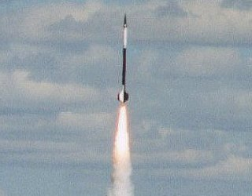

Wednesday, February 8th, 2006 at 6:00 PM
Fourth Avenue Building, room 150

Come find out what PSU's own student rocketry group has been doing since 1997! The Portland State Aerospace Society (PSAS) designs, builds, and launches the world's most advanced open source rockets, and YOU are invited to come join the fun, no matter what field you're studying.

At our introductory meeting 6pm Wednesday, February 8th in Fourth Avenue Building room 150, we will show you pictures and movies of our past flights, tell you where we are going next, and feed you. If you like what you see, we invite you to help us make our next rocket a reality.

For more information about PSAS, check out our web site at http://psas.pdx.edu or send us e-mail at info@psas.pdx.edu. As an open source project we post all of our work on the web, so you should be able to discover anything you would like to know about us there.

